CHAPTER 2-3

the equivalence of NDFSM and DFSM

Analyzing NDFSMs

- Given an NDFSM M, we can trace the execution of M by following all paths in parallel.
  - For example, if M is in q₀ and it sees an a, it can go to q₀, or q₁. So, after reading the a, we can think of M is now in {q₀, q₁}. Suppose now it sees a b. From q₀, it can go to q₀ or q₆. From q₁, it can go to q₂. So, after reading ab, M is in {q₀, q₂, q₆}. And so on. If when all the input has been read, M is in at least 1 accepting state, then it accepts. Otherwise it rejects.
  - Of course, if M has ε-edges, then the analysis is more complex.
- To handle ε-edges we introduce the function eps:K_{M}->P(K_{M}). We define eps(q), where q is some state in M, to be the set of states of M that are reachable from q following 0 or more ε-edges.

Ex2-3-1 Consider the following NDFSM M:
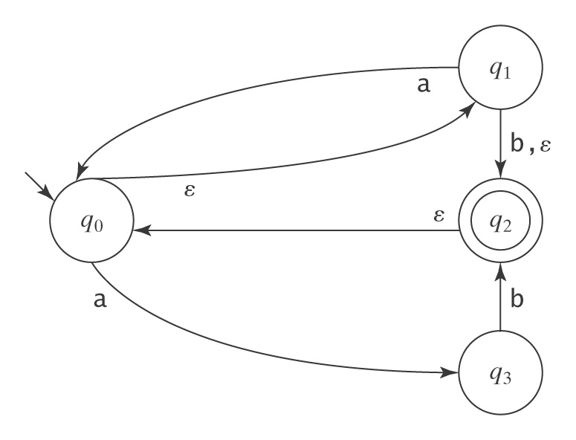
eps(q₀) =
eps(q1) =
eps(q2) =
eps(q3) =

NDFSM=DFSM

Theorem: For each DFSM, there is an equivalent NDFSM.
Proof: Let M be a DFSM that accepts some language L. M is also a NDFSM that happens to contain no ε-transitions and whose transition relation happens to be a function.

Theorem: For each NDFSM, there is an equivalent DFSM.
Proof: By construction. Given a NDFSM M = (K, Σ, Δ, s, A), we construct an equivalent DFSM M' = (K', Σ, δ', s', A'), where
s' = eps(s)
K' = P(K)
For each Q∈K' and each c∈Σ
δ'(Q, c) = ∪{eps(p):((q, c), p)∈Δ for some q∈Q}
A' = {Q∈K':Q∩A≠∅}
Construction algorithm ndfsmToDfsm(M: NDFSM)=
for each state q in K
compute eps(q)
s' = eps(s)
activeStates = {s'} //the set of states, initially only s'
δ' = ∅ //the set of transitions, initially empty
while ∃ Q∈activeStates for which δ' has not yet been computed and Q≠∅
{
for each character c in Σ
{
newState = ∅
for each state q in Q
for each state p such that ((q, c), p)∈Δ
newState = newState∪eps(p)
δ'= δ'∪{((Q, c), newState)} //line 13
if newState∉activeStates then activeStates=activeStates∪newState
}
}
K' = activeStates.
A' = {Q∈K':Q∩A≠∅}.
- When newState remains ∅ in line 13, this newState is the dead state with an Σ-loop going back to itself.

Ex2-3-2 Convert the following NDFSM to a DFSM:
-q₀
+q₁
q₂

0,1 0,1
0 1
1. eps(q₀) =
eps(q₁) =
eps(q₂) =
2. s'=
3.
4. K'=
5. A'=

Ex2-3-3 Convert the following NDFSM to a DFSM:
b
-q0
+ q₁
q₂

a ε
a

Ex2-3-4 Convert the following NDFSM to a DFSM:
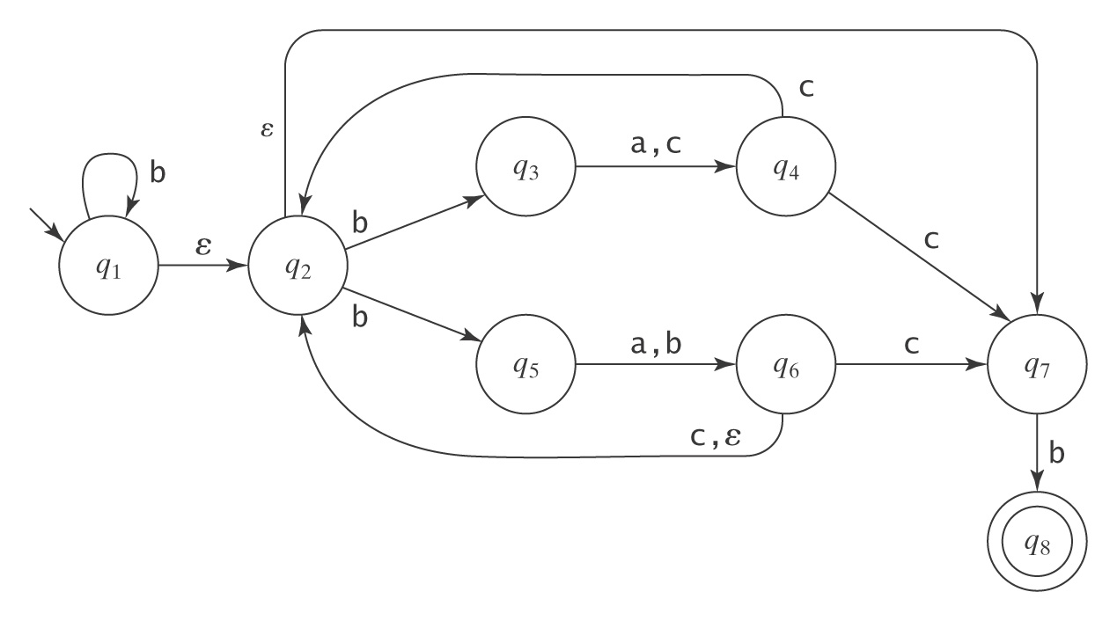

Homework problems

- Convert the following NDFSM to a DFSM using algorithm ndfsmToDfsm.
